Functional Requirement Document

Contents

Duration restriction - Changes in the table 2

Media Rights 5

Show Name 10

Stock Music 12

OAP 12

Content Deal Validation 14

## Duration restriction - Changes in the table

Existing structure

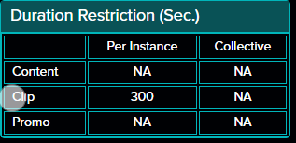

Change in Rightsline structure.

* No change in restriction of program
* Restriction on clips

There is additional data point for user to capture if there is bifurcation for fiction or non-fiction.

If there is no bifurcation, then user will select ‘No’ in the dropdown.

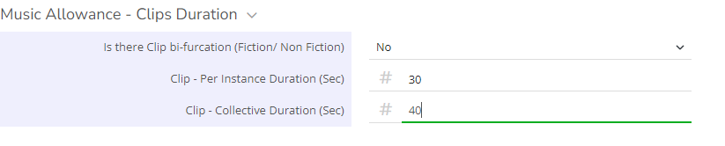

Output in table in Octave should be

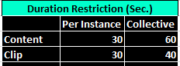

If there is bifurcation, then user will select ‘Yes’ in the dropdown.

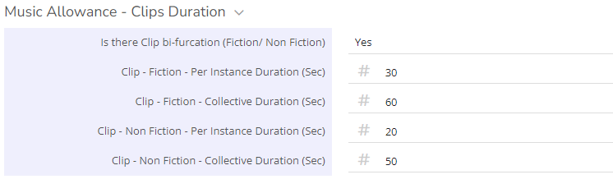

Output in table in Octave should be

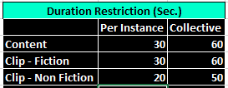

* Restriction on promo duration

There is additional data point for user to capture if there is bifurcation for restriction on duration for in context, out of context, brand, and channel promo separately.

If there is no bifurcation, then user will select ‘No’ in the dropdown.



Output in table in Octave should be

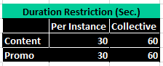

If there is bifurcation, then user will select ‘Yes’ in the dropdown.

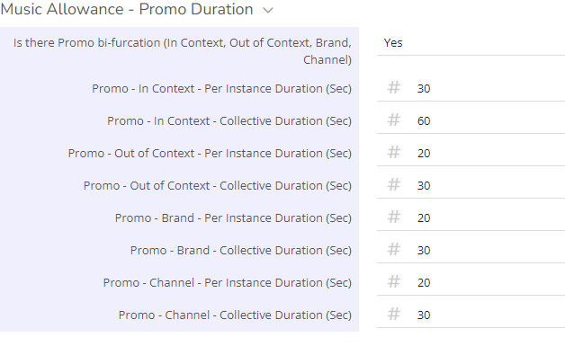

Output in table in Octave should be.

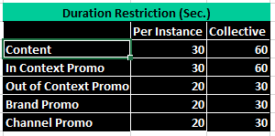

Please refer table below for the visibility of rows

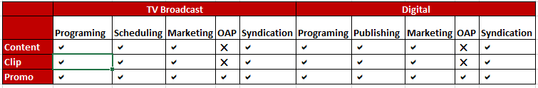

## Media Rights

Media rights in Rightsline is as below



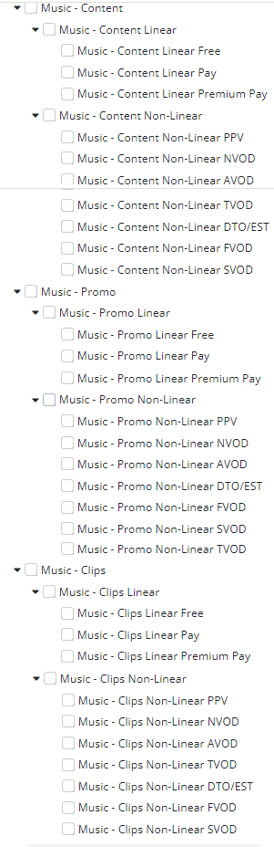

Legal updates required media rights for music in a music deal under rights tab. Existing music app output gives parent node only if it is selected in the music deal. For example, in Rightsline

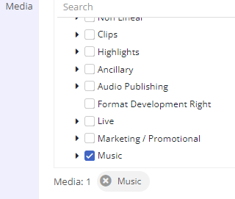

Output in Octave is

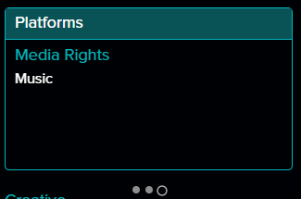

If in Rightsline,

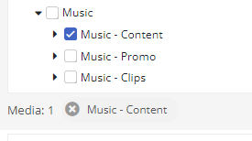

Output in Octave is

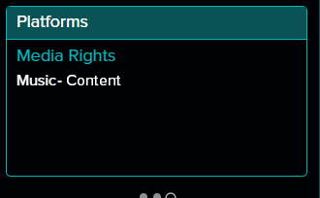

We need to change this to have detailed information with child nodes of the parent selected in media rights tree in the music deal. To achieve this, Octave needs to maintain mapping of media rights in Rightsline and the test to be displayed in output.

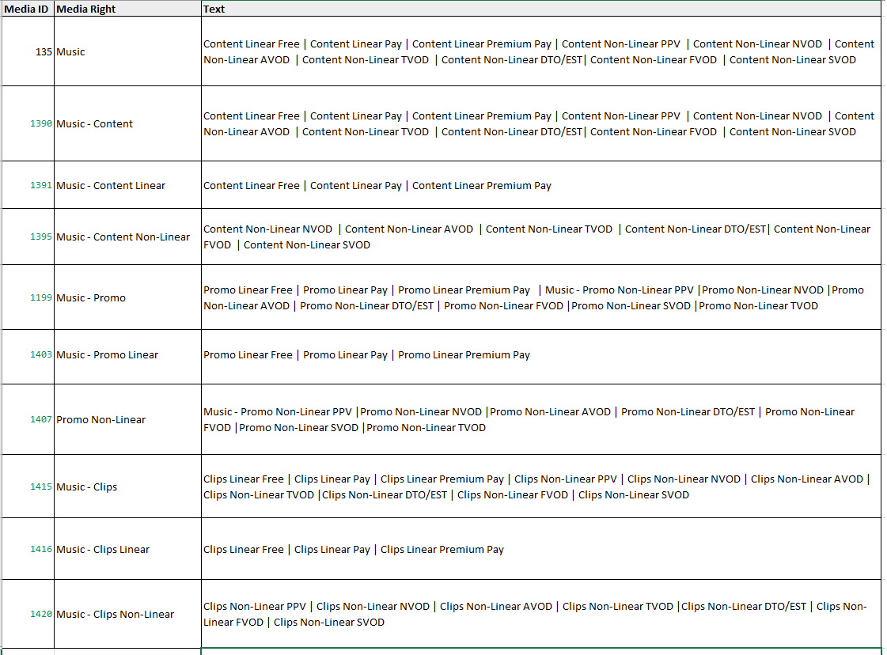



This mapping will be configurable and can be updated by ETG as and when required.

App will read the media rights ID from the Rightsline API JSON and pull the text to be displayed in the app output referring this mapping. For example,

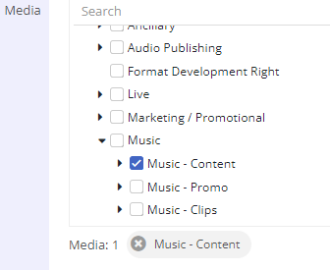

Output will be

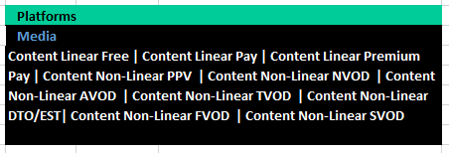

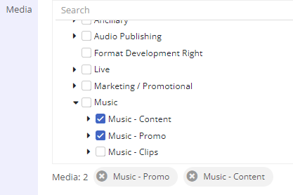

Output will be

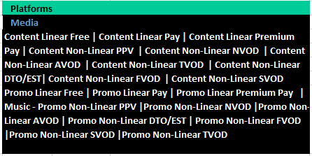

If there is information available in mapping table, Octave will display the information available in JSON as it is.

For example,

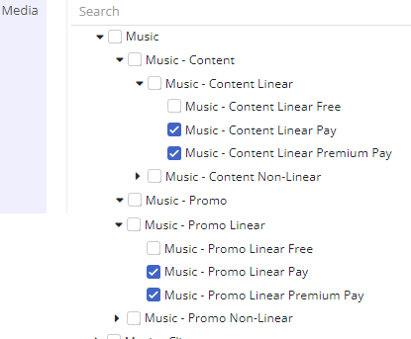

Output will be

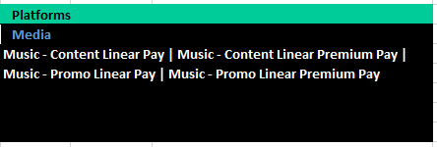

## Show Name

Currently we are having a text box to search a show name.

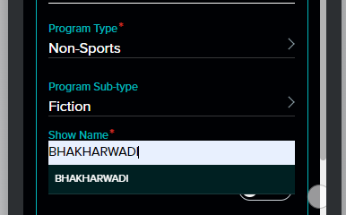

The show name is pulled from Rightsline catalog library basis the *program sub-type*. If program sub-type is ‘*Fiction’* then app pulls the catalo reading *Content type and Content sub-type.* In additional to this app will also consider ‘Owner Channel’ attribute of a catalog.

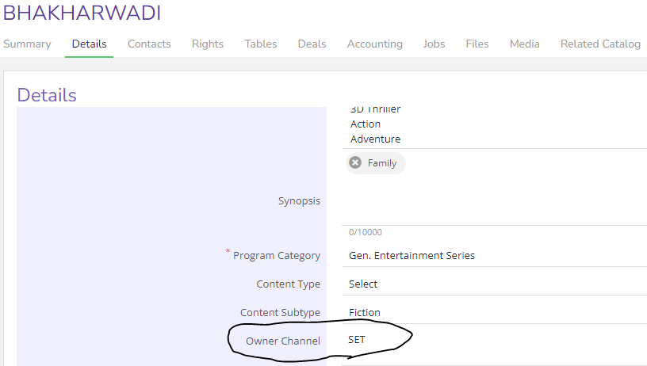

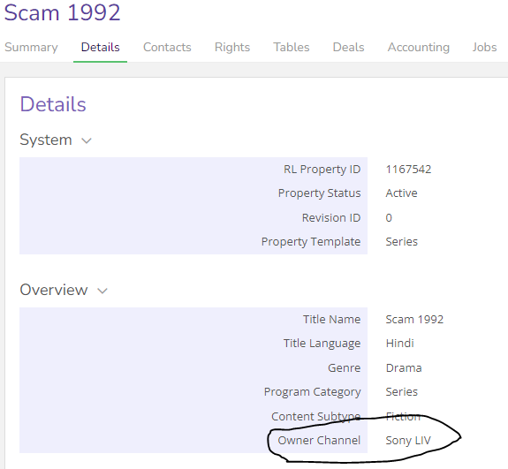

For TV Broadcast use cases pull catalog where ‘*Owner Channel*’<> Sony LIV

For Digital Sony LIV programming use cases pull catalog where ‘*Owner Channel*’ = Sony LIV

For Digital Sony LIV non programming use cases there will no filter for ‘*Owner Channel*’.

## Stock Music

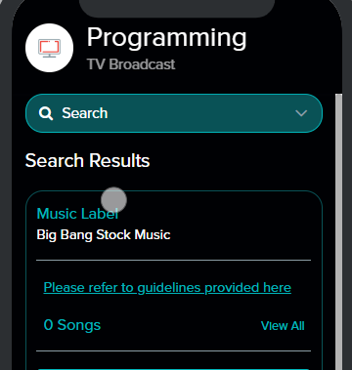

App will not show ‘0 Songs’ and ‘View All’ link if there are no songs in the library.

For [Universal Music India Pvt. Ltd.](https://app.rightsline.com/mod2/1837084), always show songs from active music repertoire /container with link to guidelines for stock music.

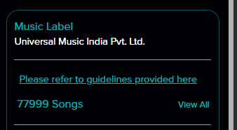

## OAP

App will have two option for OAP

* Pre-Facto (prior to episode airing)
* Post-Facto (after episode is aired)

Pre-Facto

This will be replica of programming use case

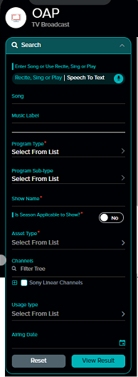

Post-Facto

This will be existing OAP use case

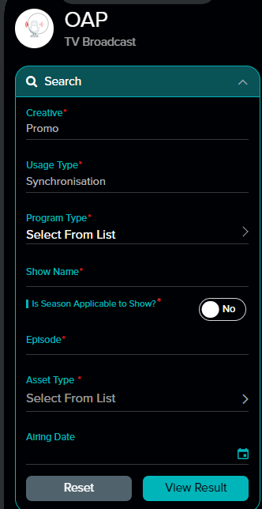

## Content Deal Validation

**TV Broadcast – Programming**

From show name selected app will get its catalog ID. Using this ID, app will call Rightsline Avails API. The output JSON will have details of rights term start and end date along with media rights details. There can be multiple line items (rights object) in JSON. Below will be the sequence to validate content deal in app

1. Rights should be active – Using rights term start and end date if any of the line item (right object) has active entry please proceed else show negative result saying ‘<selected show name> is not active
2. From the active rights object should have at least one Linear right selected.

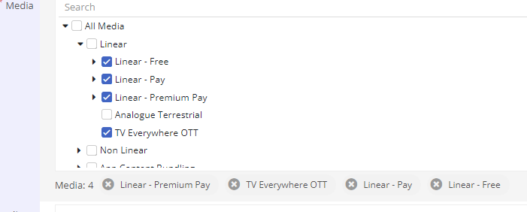

If yes then please proceed with music deal validation else show negative result saying ‘<selected show name> does not have active TV rights

**TV Broadcast – Scheduling**

From show name selected app will get its catalog ID. Using this ID, app will call Rightsline Avails API. The output JSON will have details of rights term start and end date along with media rights details. There can be multiple line items (rights object) in JSON. Below will be the sequence to validate content deal in app

1. Rights should be active – Using rights term start and end date if any of the line item (right object) has active entry please proceed else show negative result saying ‘<selected show name> is not active
2. From the active rights object should have at least one Linear right selected.



If yes then please proceed with music deal validation else show negative result saying ‘<selected show name> does not have active TV rights

1. If channels are selected from filters, validate them against the JSON. From the active rights object, if filter channels are part of JSON then proceed else show negative result saying ‘<selected show name> is does not have TV rights on <selected channels from filters>
2. If territories are selected from filters, validate them against the JSON. From the active rights object, if filter territories are part of JSON then proceed else show negative result saying ‘<selected show name> is does not have TV rights on <selected territories from filters>

**TV Broadcast – Marketing**

From show name selected app will get its catalog ID. Using this ID, app will call Rightsline Avails API. The output JSON will have details of rights term start and end date along with media rights details. There can be multiple line items (rights object) in JSON. Below will be the sequence to validate content deal in app

1. Rights should be active – Using rights term start and end date if any of the line item (right object) has active entry please proceed else show negative result saying ‘<selected show name> is not active
2. From the active rights object should have at least one Linear right selected.



If yes then please proceed with music deal validation else show negative result saying ‘<selected show name> does not have active TV rights

1. Check for clip rights

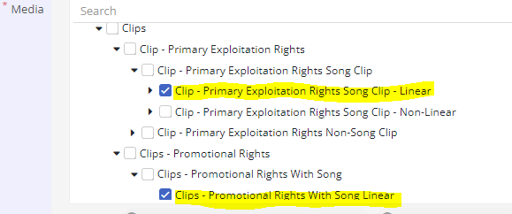

Active rights object should have at lease one of the clip rights highlighted above in JSON. If yes then proceed with music deal validation else show negative result saying ‘<selected show name> does not have active clip rights for TV

**TV Broadcast – OAP**

From show name selected app will get its catalog ID. Using this ID, app will call Rightsline Avails API. The output JSON will have details of rights term start and end date along with media rights details. There can be multiple line items (rights object) in JSON. Below will be the sequence to validate content deal in app

1. Rights should be active – Using rights term start and end date if any of the line item (right object) has active entry please proceed else show negative result saying ‘<selected show name> is not active
2. From the active rights object should have at least one Linear right selected.



If yes then please proceed with music deal validation else show negative result saying ‘<selected show name> does not have active TV rights

1. Check for promo rights

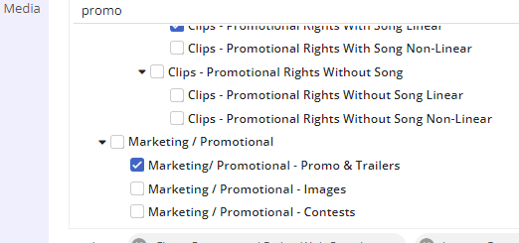

If the active rights object has details of either Marketing/promotional rights (top most node) of Marketing/promotional – Promos & Trailers (child node) selected then proceed with music deal validation else show negative result saying ‘<selected show name> does not have promo rights for TV